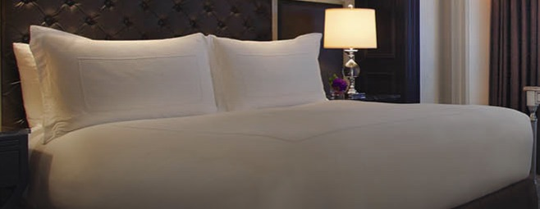

T300 100% cotton bedding sets

Include:
1 flat sheet
1 fitted sheet
2 pillow cases
1 duvet cover with embroidered white square

Double set $140.00
Queen set $160.00
King set $170.00
